Retail Sales Part 1: Data Cleaning

Overview
For this project we will be cleaning and analyzing our retail sales data. The aim is to provide decision makers with recommendations on sales and purchasing strategies.

TABLES
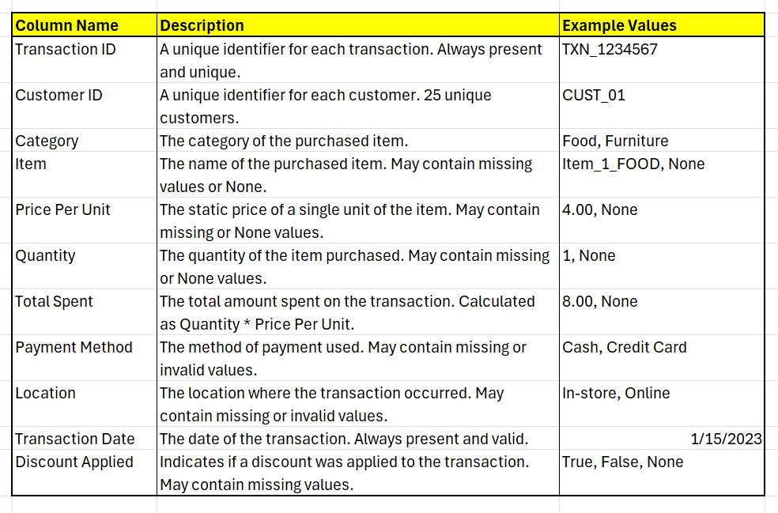
- Retail Sales (See table description provided by data author below)

- Category tables (only 2 / 9 available)
  - Each contains 25 records with corresponding codes, names, and static prices.
  - All category tables follow the same pattern (See table description below)
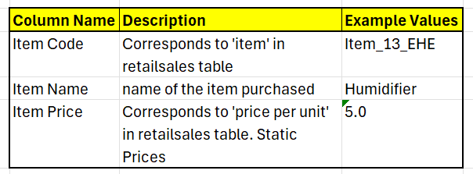

Actions Taken
- Loading & formatting tables
- Entered all missing data in Categories table, except for 'itemname'. Code obtained from GEMINI.
- Remove duplicates from both tables
- Standardizing columns
  - Remove trailing spaces
  - Finding values that can be booked together
  - Change spelling
- Null handling
- Relevance of ‘discountapplied’ column in RetailSales table
- Conclusion

Loading & Formatting Tables
First we load the tables into pgadmin. We’ve loaded both category tables in the same ‘categories’ table. We’ve also formatted the columns when importing.
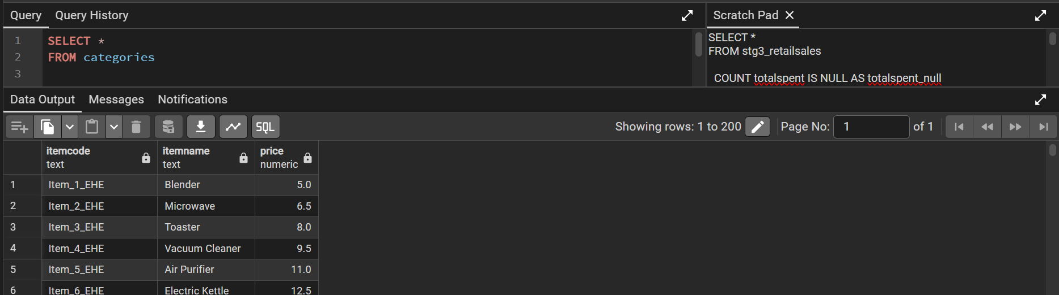
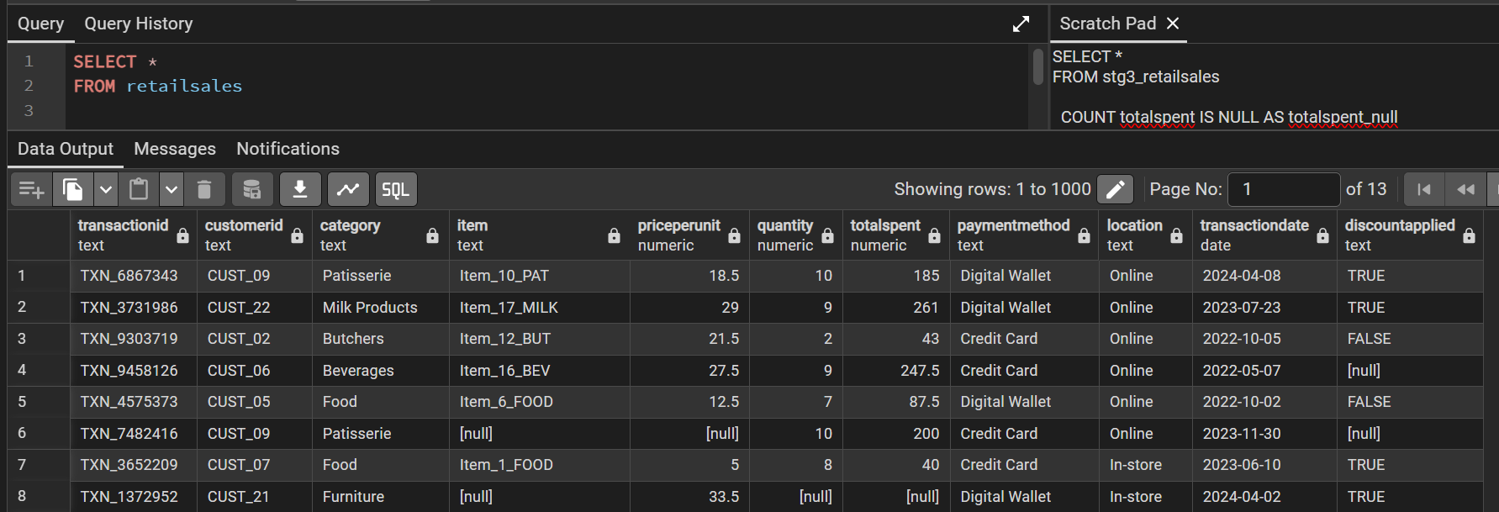

Entering missing data in Categories table
Fill in all data excluding ‘itemname’. Code from Gemini below.
WITH SourceData AS (
-- Generate the item number (1 to 25) dynamically using ROW_NUMBER()
SELECT
price,
ROW_NUMBER() OVER () AS item_num -- Assigns 1, 2, 3... to each price row
FROM
(VALUES
(5.0), (6.5), (8.0), (9.5), (11.0),
(12.5), (14.0), (15.5), (17.0), (18.5),
(20.0), (21.5), (23.0), (24.5), (26.0),
(27.5), (29.0), (30.5), (32.0), (33.5),
(35.0), (36.5), (38.0), (39.5), (41.0)
) AS t(price) -- Alias 't' is required, price is the column name for the values
),
Suffixes (suffix) AS (
VALUES
('CEA'), ('FOOD'), ('BEV'), ('MILK'), ('PAT'), ('BUT')
)
INSERT INTO categories (itemcode, itemname, price)
SELECT
-- Use the calculated item_num, converting it to text
'Item_' || sd.item_num::TEXT || '_' || s.suffix,
NULL,
sd.price
FROM
SourceData sd
CROSS JOIN
Suffixes s;
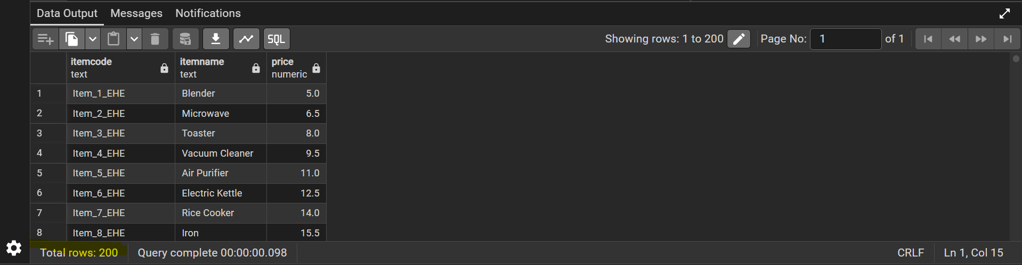

Removing Duplicates
We created a staging categories table as we will be deleting rows, and add a ROW_NUMBER col grouped by itemcode (has distinct values only).
CREATE TABLE stg_categories AS (
SELECT *,
ROW_NUMBER () OVER ( PARTITION BY itemcode) AS rownum
FROM categories
);
The table below is ORDER BY rownum DESC
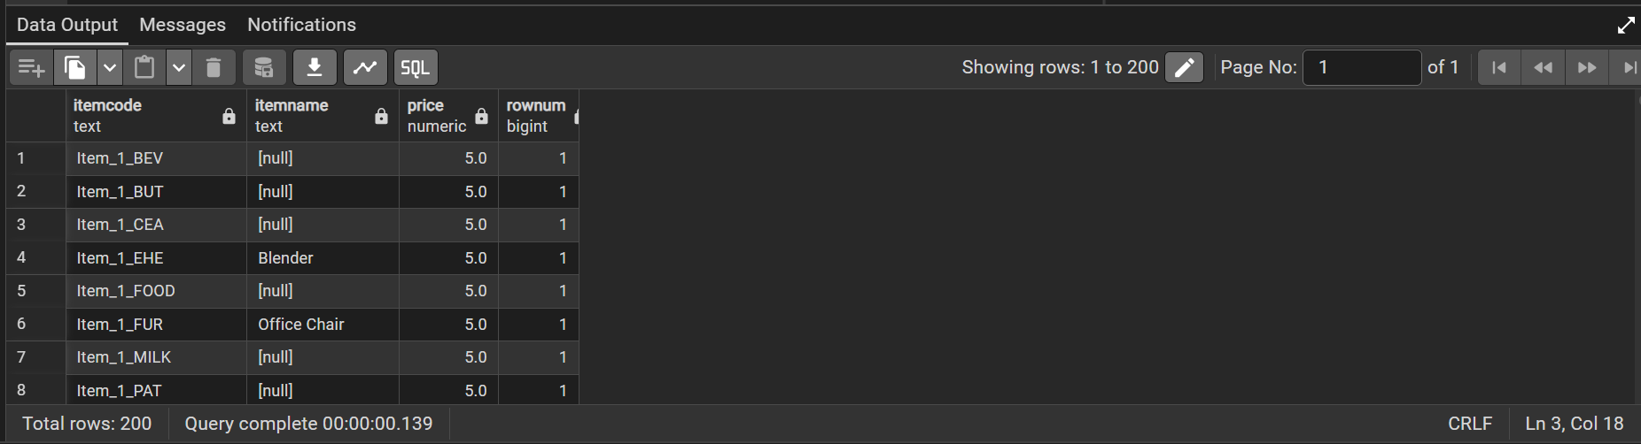
There are no duplicates, so we remove the rownum col.
ALTER TABLE stg_categories
DROP COLUMN rownum;

Now we create a staging retailsales table, and add a ROW_NUMBER col grouped by transactionid(has distinct values only) and check for duplicates. The queries were run separately
CREATE TABLE stg_retailsales AS
SELECT *,
NOW() AS load_timestamp,
'NA' AS source_system_name,
ROW_NUMBER() OVER (PARTITION BY transactionid ) AS rownum
FROM retailsales;

SELECT *
FROM stg_retailsales
WHERE rownum > 1;
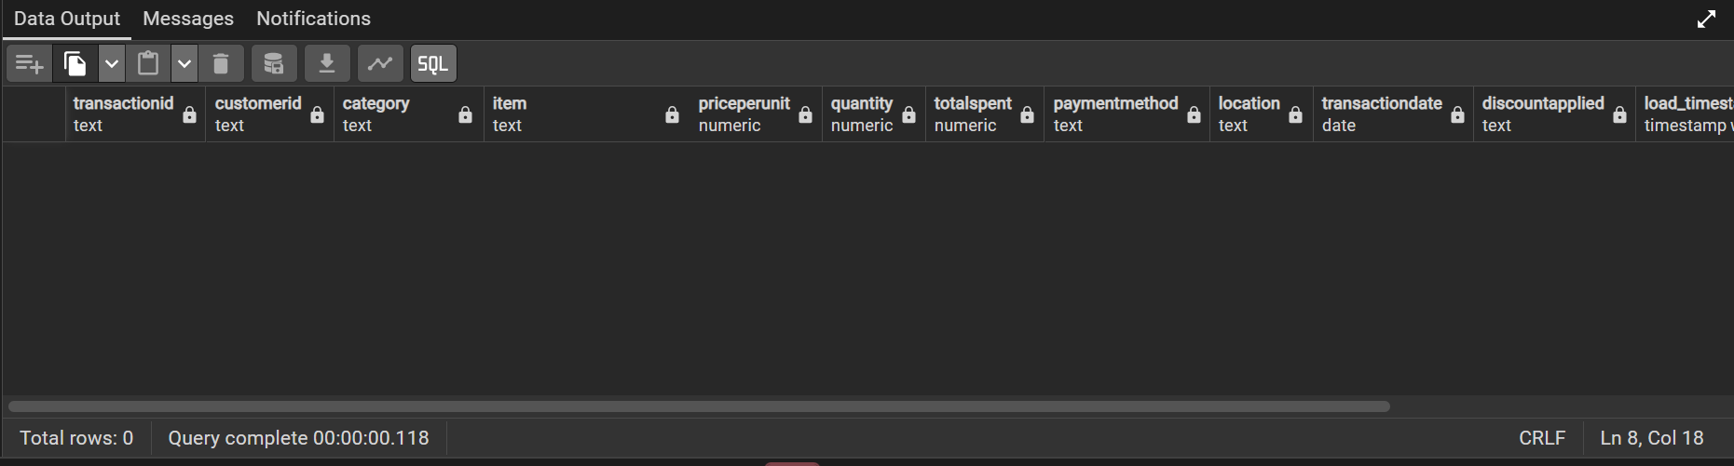
There are no duplicates. Delete rownum.
ALTER TABLE stg_retailsales,
DROP COLUMN rownum;

Standardizing Data
Create another staging retailsales table, as we will be making a lot of permanent changes. All columns are selected. We didn’t use SELECT * to avoid copying the load_timestamp and source_systemname from the previous staging table.
CREATE TABLE stg2_retailsales AS
SELECT
transactionid,
customerid,
category,
item,
priceperunit,
quantity,
totalspent,
paymentmethod,
location,
transactiondate,
discountapplied,
NOW() AS load_timestamp,
'NA' AS source_system_name
FROM stg_retailsales;
Now we remove all the trailing spaces from our stg2_retailsales table.
UPDATE stg2_retailsales
SET
transactionid = TRIM(transactionid),
customerid = TRIM(customerid),
category = TRIM(category),
item = TRIM(item),
paymentmethod = TRIM(paymentmethod),
location = TRIM(location),
discountapplied = TRIM(discountapplied)
WHERE
transactionid LIKE ' %' OR transactionid LIKE '% ' OR
customerid LIKE ' %' OR customerid LIKE '% ' OR
category LIKE ' %' OR category LIKE '% ' OR
item LIKE ' %' OR item LIKE '% ' OR
paymentmethod LIKE ' %' OR paymentmethod LIKE '% ' OR
location LIKE ' %' OR location LIKE '% ' OR
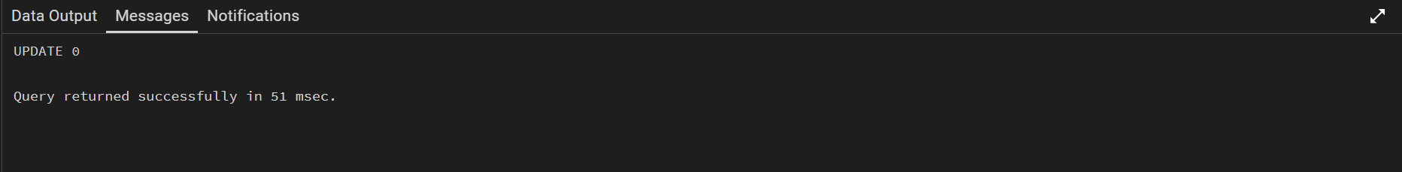
discountapplied LIKE ' %' OR discountapplied LIKE '% ';
The output message shows that there are no text columns with trailing spaces.
We also created another staging table for categories and trimmed the columns. Likewise, there are no trailing spaces in text columns.
-- create stg2_categories
CREATE TABLE stg2_categories AS
SELECT
itemcode,
itemname,
price,
NOW() AS load_timestamp,
'NA' AS source_system_name
FROM stg_categories;
-- trim stg2_categories
UPDATE stg2_categories
SET
itemcode = TRIM(itemcode),
itemname = TRIM(itemname)
WHERE
itemcode LIKE '% ' OR itemcode LIKE ' %' OR
itemname LIKE '% ' OR itemname LIKE ' %';
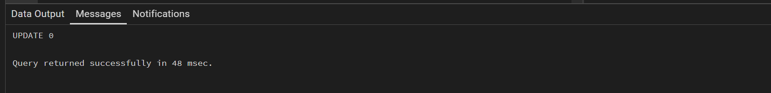

We also looked for records that can be grouped together, ie ewallet and GooglePay. We ran each of the queries below separately.
-- category column
SELECT DISTINCT(category)
FROM stg2_retailsales
ORDER BY category;
-- paymentmethod
SELECT DISTINCT(paymentmethod)
FROM stg2_retailsales;
-- location
SELECT DISTINCT(location)
FROM stg2_retailsales;
-- item
SELECT DISTINCT (item)
FROM stg2_retailsales
ORDER BY item;
-- discountapplied
SELECT DISTINCT (discountapplied)
FROM stg2_retailsales;
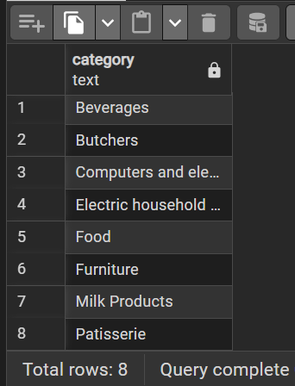
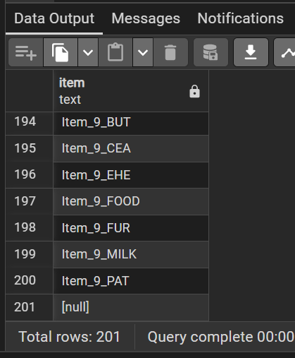
Example Outputs are as shown below. We’ve notice some spelling errors.

We made a spelling change as shown below
UPDATE stg2_retailsales
SET category = 'Milk products'
WHERE category = 'Milk Products';
We also changed the data type for quantity from numerical to integer
ALTER TABLE stg2_retailsales
ALTER COLUMN quantity TYPE INTEGER

Null Handling
Next we found which columns in stg2_retailsales & stg2_categories had nulls, by counting the number or null records.
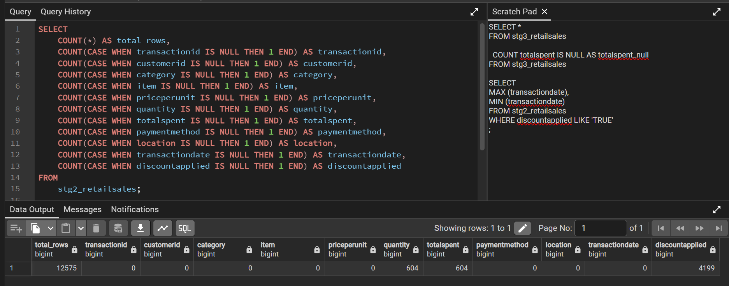
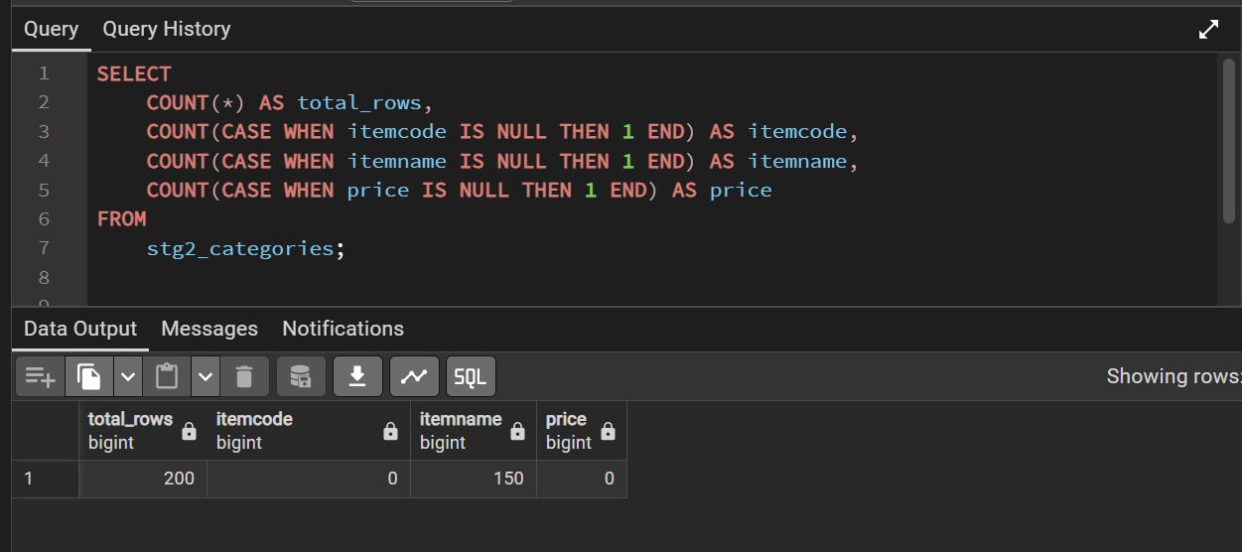
We added a ‘itemcategory’ column to stg2_categories. This will help us fetch the other 2 columns to update the stg2_retailsales table
-- addcol stg2_categories.itemcategory
ALTER TABLE stg2_categories
ADD COLUMN itemcategory text;
-- update stg2_categories.itemcategory
UPDATE stg2_categories
SET itemcategory = stg2_retailsales.category
FROM stg2_retailsales
WHERE itemcode = stg2_retailsales.item;
-- view table
SELECT *
FROM stg2_categories

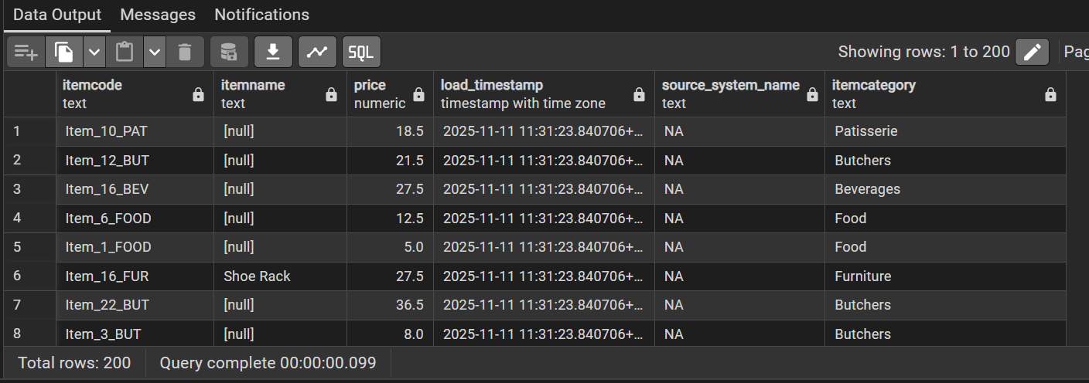
We also checked for nulls in the newly updated itemcategory column
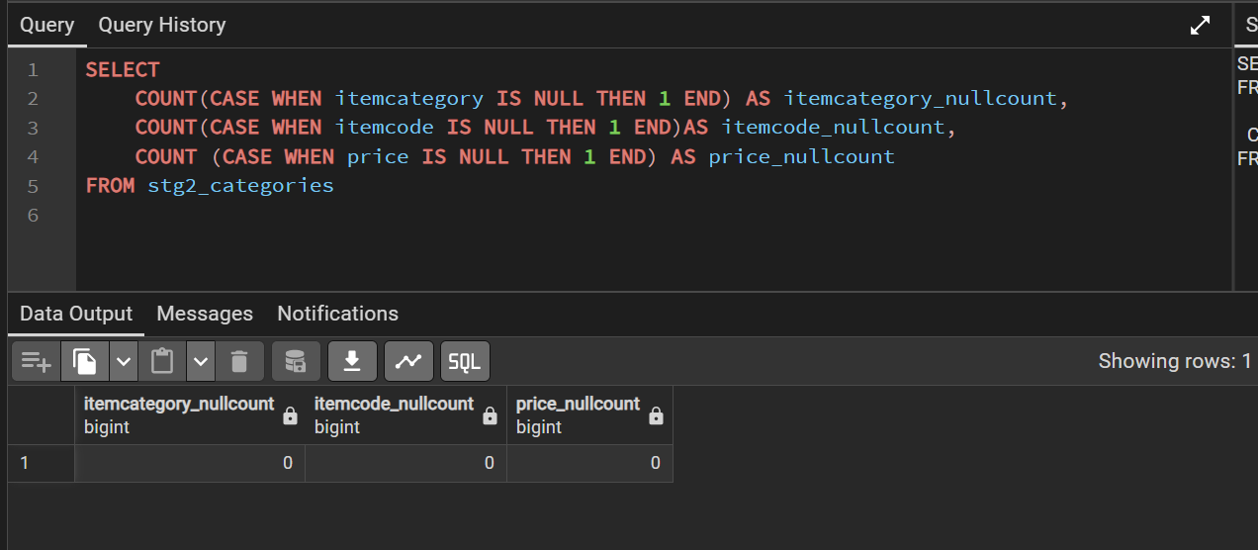
Since there are no nulls in itemcategories, we proceeded to use the stg2_categories table to fill up the stg2_retailsales table. We ran these queries separately.
--update stg2_retailsales.quantity
UPDATE stg2_retailsales
SET quantity = totalspent / priceperunit
WHERE quantity IS NULL;
--update stg2_retailsales.totalspent
UPDATE stg2_retailsales
SET totalspent = priceperunit * quantity
WHERE totalspent IS NULL;
-- update stg2_retailsales.priceperunit
UPDATE stg_retailsales
SET priceperunit = totalspent/quantity
WHERE priceperunit IS NULL
--update stg2_retailsales.item
UPDATE stg2_retailsales AS r
SET item = c.itemcode
FROM stg2_categories AS c
WHERE r.priceperunit = c.price
AND r.category = c.itemcategory
AND r.item IS NULL

After that, we checked the stg2_retailsales table for nulls again.
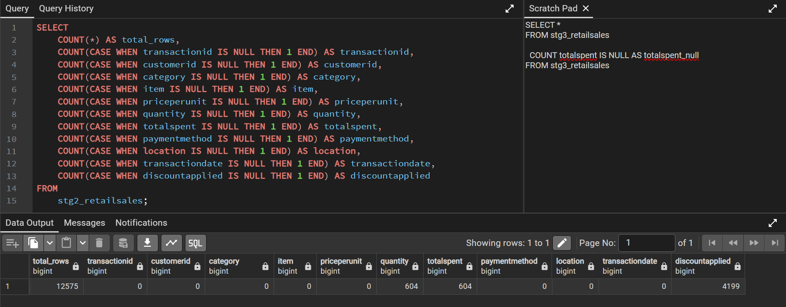
Quantity, totalspent, discountapplied has nulls. We checked to see if there were rows with both quantity & totalspent as null.
SELECT
COUNT (CASE WHEN quantity IS NULL THEN 1 END) AS quant_null,
COUNT (CASE WHEN totalspent IS NULL THEN 1 END) AS totalspent_null,
COUNT (CASE WHEN quantity IS NULL or totalspent is null then 1 end) as OR,
COUNT (CASE WHEN quantity IS NULL AND totalspent IS NULL then 1 end) AS AND
FROM stg2_retailsales
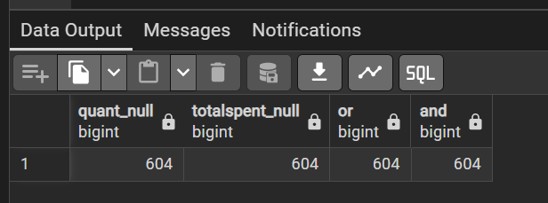

There are nulls for both columns in the AND section of the query.

Relevance of ‘discountapplied’ column in RetailSales table
We checked if we can use totalspent/quantity <> priceperunit can help us determine which customers used discounts.

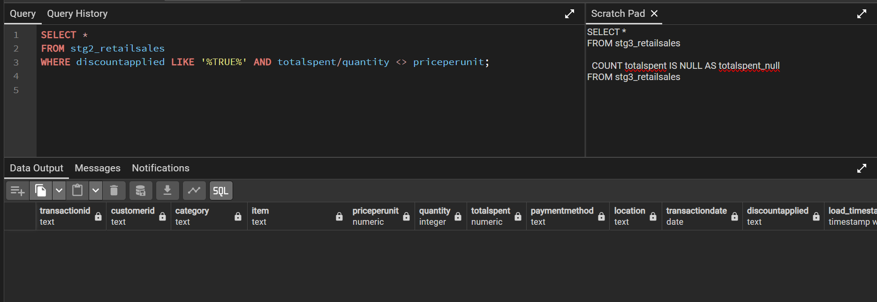
The output shows that totalspent and price per unit does not indicate that the discount is used. It is possible that this table just does not list discounted prices. Next, we tried testing if discounts are only applicable for certain items.
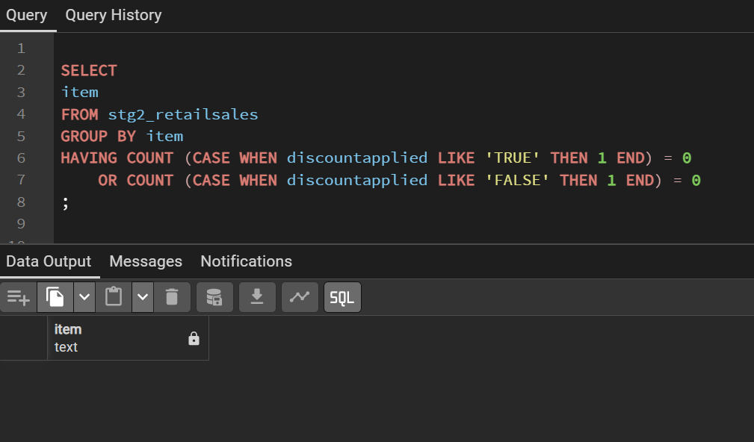
We also checked to see it discountapplied is affected by transaction date range
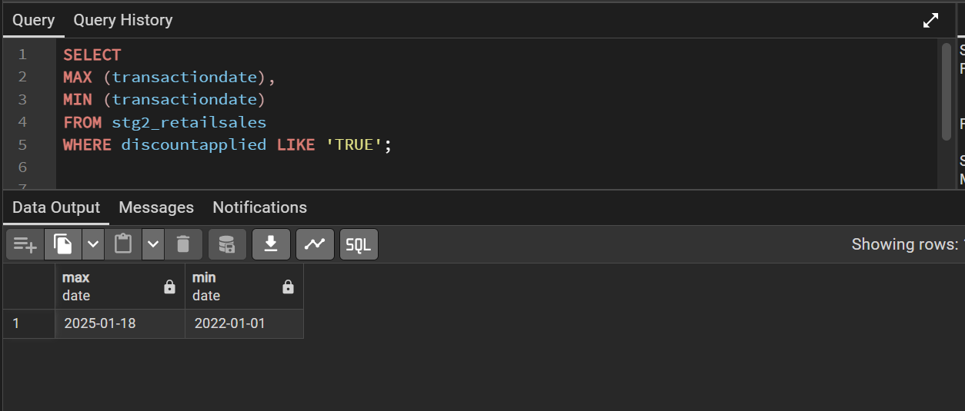
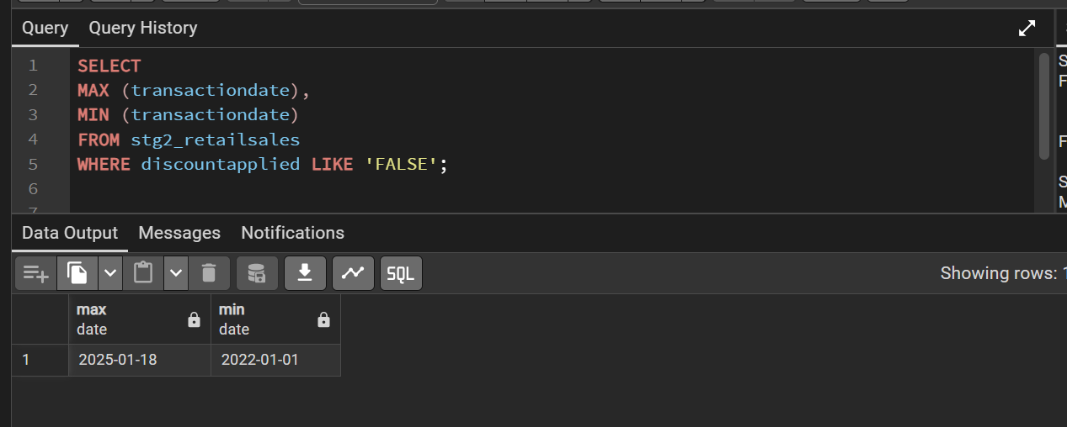
Discountapplied is not affected by transactiondate.
Discountapplied is not affected by paymentmethod either, as shown below
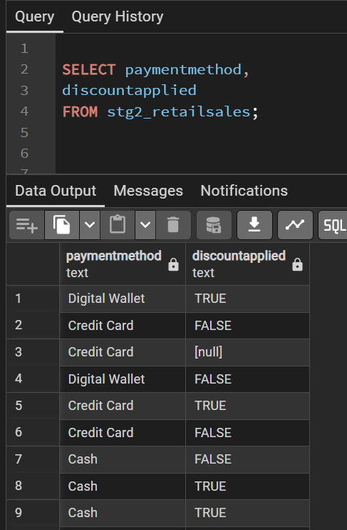

Conclusion
There are still null values in the quantity, totalspent and discounts columns in the retailsales table.
- Records with nulls in the quantity column also have nulls in the totalspent column. It is not possible to derive the missing values anywhere else.
- It is possible that discounts have been applied, but this table does not list discounted prices.

